A
Synopsis Report
On
Title of Project
For
partial fulfillment of award of the
B. Tech Degree in Information Technology

Under the Supervision of
(mention your supervisor name)

Submitted by:


Session:
G. L. Bajaj Institute of Technology and Management,
Greater Noida

TABLE OF CONTENTS

1. Introduction
2. Relevant Work\Existing System\ Literature Review
3. Proposed work
4. Methodology/Experimental Work
5. Conclusion
6. Future Scope

INTRODUCTION
News has been the provider of information since centuries. In traditional times, there were news agencies which were the source of news and hence, reliability and confidentiality remained with the official organizations itself. In recent times, internet grew rapidly from rural to urban areas. With the growth of internet, more users from all over the world got access to internet and to spread the information in their way [1].
According to Economic Times report of 2019, there are 627 million internet users in India which means India is home to world’s second largest internet user base [2]. However, with the increasing popularity of social media, the internet becomes ideal breeding ground for fake news. A research by BBC shows that nearly 72% Indians struggled to distinguish between fake and real news [3]. Websites like The Onion[4], News Thump[5], The Poke News[6], and The Mash News[7] are among the top rankers of ‘Fake’ or ‘misleading’ news propagator [8]. Hence, many online fact checking resources like Snopes[9], FactCheck.org[10], Factmata.com[11], PolitiFact.com[12] and many more grew rapidly. Social networking sites such as Facebook, Whatsapp, and Google addressed this particular concern but the efforts hardly contributed in solving the issue.
Approaches to detect Fake News:
- Detection Approaches Based on Machine Learning: Support Vector Machines (SVMs), Random forests, logistic regression models, Conditional Random Field (CRF) classifiers, Hidden Markov Models (HMMs) [13].
- Detection approaches based on deep learning: The two most widely implemented paradigms in modern artificial neural networks are Recurrent Neural Networks (RNN) and Convolutional Neural Networks (CNN) [13].
This model will detect fake news by checking the credibility of the news provider, comment sentiment analysis and content of the provided news. We will be using Natural Language Processing for pre-processing the dataset and machine learning approach to fight fake news.

Figure 1: Fact Checker [14]
BACKGROUND
There are many models for fact checking and detecting fake news. PolitiFact[12] - A fact-checking website operated by Poynter Institute in St. Petersburg, Florida which uses Truth-O-Meter to determine truthfulness of a statement/article/event/Image/video. But the fact checking is limited to political news and hence fails to cover broad spectrum of news. According to a survey paper, Facebook fake news sources can be encountered using BS Detector[15]. Another fact checking website, Factmata[11] provides platform to get better understanding of the content by providing scores content on nine signals, including Hate speech and Political bias, to give us a deep understanding of credibility and safety of any content on web. Messenger for businesses Flock has launched Fake news detector that aims to stop false and misleading information from being introduced in their environment [16].
In India, fact check has recently been launched by India Today, Times of India, and AFP India but these resources do not provide platform for users to check whether the news article they are viewing is fake or real. AltNews [17] has been successful in India to provide platform for user to clear their doubt, though it is yet to get more efficient and reliable.
Models like Fact Finder, only check whether the news is fake or real. On the other hand, AltNews website or app works on fake news and publish viral fake news articles. Our model, performs both work simultaneously.

PROPOSED WORK

In this paper a model is build based on pre-processing data with the use of NLTK library, removing all the stopwords such as “the”, “is”, and “are” and only using those words which are unique and provide us with relevant information. We also removed punctuations, numbers and converted our dataset into lowercase letters. Also we have used Count Vectorizer or TF-IDF matrix which tallies to how often the word in used in a given article in our dataset, Figure 2 depicts the process from collecting News Articles Dataset to using News Classification Algorithm. Since the problem concerns with text classification and information extraction, we have used Naïve Bayes classifier for text-based classification. For training and testing, we have used Multinomial NB and Passive Aggressive Classifier with 33% training dataset. We will also remove rare words occurring in our corpus with the help of Count Vectorizer [18-20].

The goal of the project is to make a website and app for user so that whenever he/she selects a text, the app reflects with floating window and provides user with the percentage of fake and real news of the selected text. The advantage with the app or website is that without opening or uploading any content in the app, the app will detect fake news.
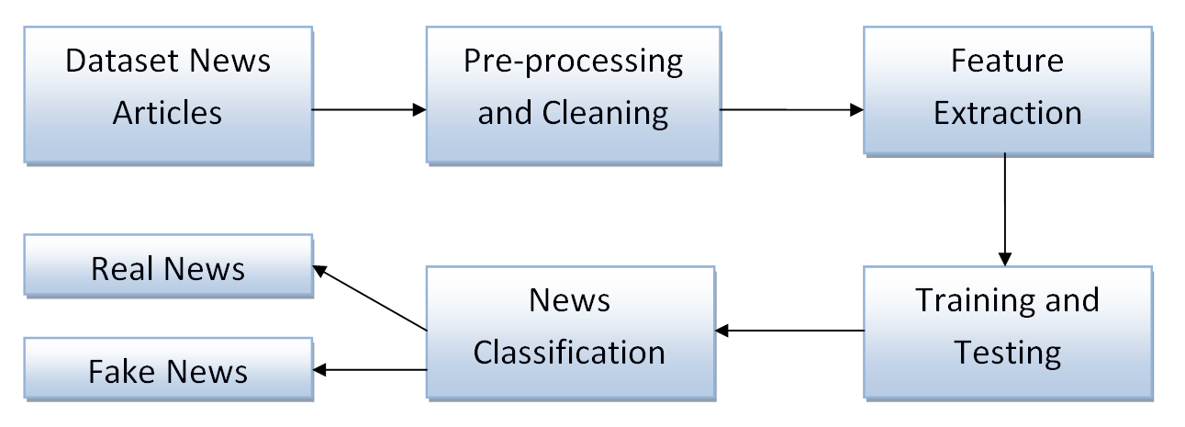Figure 2: Process Flow Diagram
METHODOLOGY
In this section, methodology of proposed model has been described. Figure 3 represents work flow of methods involved in creating the model. The major steps involved in building the model are:

Corpus of Text Document

Text wrangling and pre-processing

Parsing and Basic Exploratory Data Analysis

Text representation using relevant feature engineering techniques

Modeling

Evaluation and Deployment


Figure 3: Methodology
Scraping News Articles for Data Retrieval
Currently, the model has been trained using dataset from Kaggle [21] with 6335 rows and 4 columns. News articles will be scraped from, inshorts [22], with the help of python libraries along with NLTK and spacy. A typical news article is also in the HTML section as depicted in the following image:
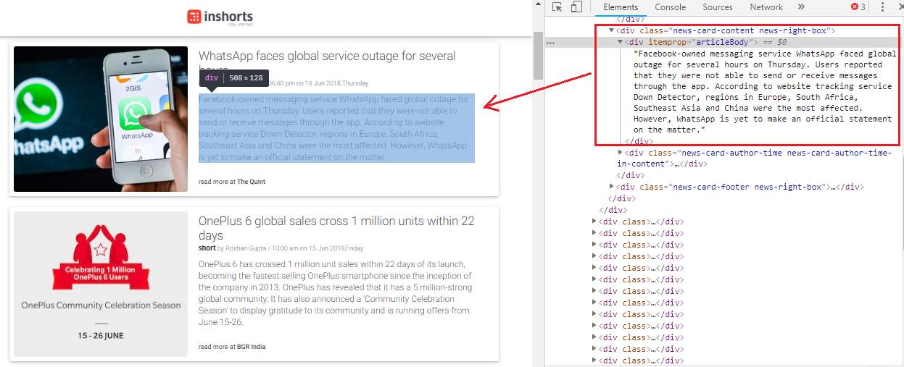
Figure 4: The landing page for technology news articles and its corresponding HTML structure [23]
The specific HTML tags can also be used which contain the textual content [24]. Hence, with the help of libraries such as BeautifulSoup and requests, useful content will be scraped.
Collected dataset contains 6335 rows and 4 columns; the head of the dataset has been depicted in the following Figure 5:
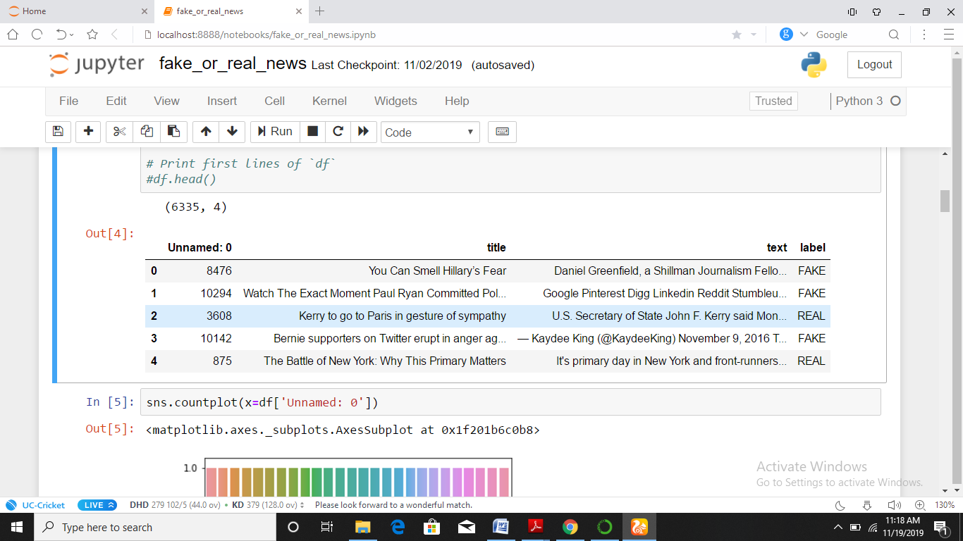
Figure 5: Dataset of real and fake news articles

Text Wrangling, Cleaning and Pre-processing
Here, the nltk and spacy packages both have been leveraged to process the data. Stopwords can be used to process data and remove the most common words used in our dataset such as “and”,”the” and “is”. Along with stop words, HTML tags, accented text, expand contractions, punctuations, numbers, and special characters are also needed to be removed since they do not provide relevant information. Lemmatizing and stemming text are done with the help of functions such as lemmatize_text() and simple_stemmer() respectively.
With the help of TF-IDF vectorizer, word importance in a given article in the entire corpus is determined. [25]
Data Visualization and Feature Extraction
For better understanding of the dataset, we use matplotlib and seaborn libraries for visualization and plotting graphs. Using stripplot() method, present in seaborn library statistical plot as depicted in Figure 6 was formed which shows 0~5000, datasets are REAL while from 5000~10000, datasets are FAKE. CountVectoriser library to remove the rare words was imported.
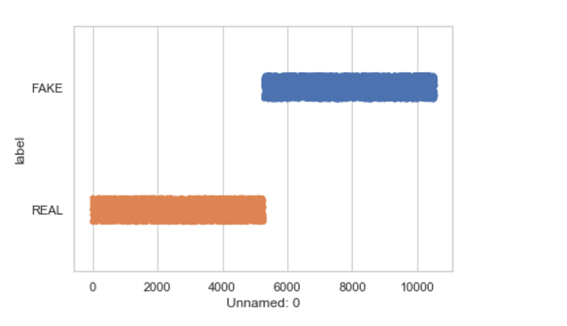
Figure 6: Dataset Visualization of Fake news and Real news using Seaborn
X-axis represents label(fake or real), y-axis represents Index
Modeling and Grid Search

With the help of Multinomial NB and Passive Aggressive Classifier, 33% of the dataset was trained and testing rest 67%. Using confusion matrix, highest accuracy model will be achieved. [26]
Experimental and Result Analysis
Let’s consider the result as positive, when the classifier classifies news articles as fake:
- The number of True Positives is the number of news articles correctly classified as Fake News;
- The number of False Positives is the number of news articles incorrectly classified as Fake News;
- The number of True Negatives is the number of news articles correctly classified as True News;
- The number of True Positives is the number of news articles incorrectly classified as True News;

The precision of a classifier is calculated as follows:

Precision = tp / (tp + fp)
where:
tp – number of true positive examples;
fp – number of false positive examples.
The recall of a classifier is calculated as follows:

Recall = tp / (tp + fn), (27)

where fn is a number of false negative examples.
As depicted in figure 7, confusion matrix helps in evaluating the quality of the output of a classifier, in this case being, Multinomial NB and Passive Aggressive Classifier, on the fake or real news dataset. Diagonal elements of the matrix represents number of points where predicted label is equal to true label while off-diagonal matrix of the matrix represents number of points where prediction of the model fails.
The figure shows the matrix without normalization. Here the results of the matrix changes as the classification models or vectorizers are changed.
In Matrix 1, combination of Multinomial NB and Tf-Idf Vectoriser
In Matrix 2, combination of Multinomial NB and Count Vectoriser
In Matrix 3, combination of Passive Aggressive Classifier and Tf-Idf Vectoriser
In Matrix 4, combination of Passive Aggressive Classifier and Hashing Vectoriser

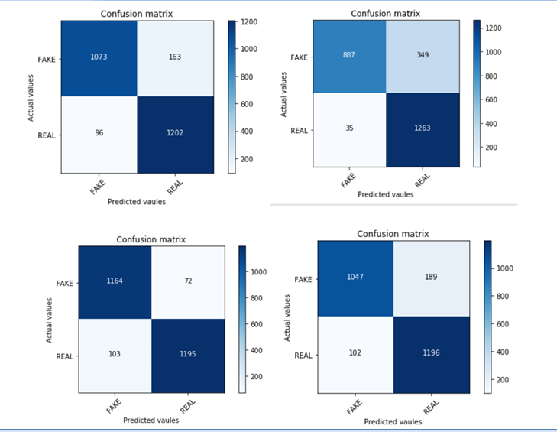
Figure 7: Confusion Matrix, without normalization

The precision for the given classifying model is 0.902; recall on the other hand is 0.486.

The precision of the model represents the relevant instances among the retrieved instances, while recall is the fraction of total amount of relevant instances that were actually retrieved.

CONCLUSION AND FUTURE SCOPE
In this project, the proposed model is Fake News Detection which differentiates the text by text classification algorithms to tell whether the news is ‘fake’ or ‘real’. For training, 33% dataset has been used, and 67% data has been used for testing the FND model. The model predicted fake and real news successfully with 90.2% accuracy.
In future, VADER for sentiment analysis can be used which is more efficient algorithm and a text classification model that provides us with highest accuracy. Also, existing Fake News Detection models have worked for news and politics only, scope in Stock Markets, where shares rise and fall very frequently, still persists.

REFERENCES
- Kuriakose, Ammu, et al. "ALIKAH-A Clickbait and Fake News Detection System using Natural Language Processing." 2019 3rd International Conference on Trends in Electronics and Informatics (ICOEI). IEEE, 2019.
- “India has second highest number of Internet users after China” - economictimes.com, 2019[Online]. Available : https://economictimes.indiatimes.com
- “Ordinary Indians are fueling the country’s fake-news crisis” – qz.com, 2018[Online]. Available: https://qz.com/india
- “The Onion” – theonion.com [Online]. Available: https://www.theonion.com/
- “News Thump” – newsthump.com [Online]. Available: https://newsthump.com/
- “Poke News” – pokenews.com [Online]. Available:
https://thepoke.co.uk/category/news/
- “Mash News” – mashnews.com [Online].
Available: https://www.thedailymash.co.uk/news
- “Top 50 Fake News Websites And Blogs on the Web in 2019” – blog.feedspot.com, 2019[Online]. Available: https://blog.feedspot.com/fake_news_blogs/
- “Snopes” – snopes.com [Online]. Available: https://www.snopes.com/
- “FACTCHECK.ORG” – factcheck.org [Online]. Available: https://www.factcheck.org/
- “FACTMATA” – factmata.com [Online]. Available: https://factmata.com/
- “Fact Checking U.S. Politics | PolitiFact ” – politifact.com [Online].
Available: https://politifact.com/
- Bondielli, Alessandro, and Francesco Marcelloni. "A survey on fake news and rumour detection techniques." Information Sciences 497 (2019): 38-55.
- “Protecting the EU Elections From Misinformation and Expanding Our Fact-Checking Program to New Languages” – aboutfb.com[Online]. Available: https://about.fb.com/news
- "B.S. Detector - Browser extension to identify fake news sites", Bsdetector.tech, 2018. [Online]. Available: http://bsdetector.tech/.
- “Messenger platform Flock launches feature to identify fake news”, economictimes.com, 2019 [Online]. Available: https://m.economictimes.com/small-biz
- “Alt News”, altnews.com [Online]. Available: https://www.altnews.in/
- N. J. Conroy, V. L. Rubin, and Y. Chen, “Automatic deception detection: Methods for finding fake news,” Proceedings of the Association for Information Science and Technology, vol. 52, no. 1, pp. 1–4, 2015.
- S. Feng, R. Banerjee, and Y. Choi, “Syntactic stylometry for deception detection,” in Proceedings of the 50th Annual Meeting of the Association for Computational Linguistics: Short Papers-Volume 2, Association for Computational Linguistics, 2012, pp. 171–175.
- Shlok Gilda,Department of Computer Engineering, Evaluating Machine Learning Algorithms for Fake News Detection,2017 IEEE 15th Student Conference on Research and Development (SCOReD)
- “Kaggle”, kaggle.com [Online]. Available: https://kaggle.com
- “inshorts - stay informed”, inshorts.com [Online]. Available: https://inshorts.com
- “A Practitioner's Guide to Natural Language Processing (Part I) — Processing & Understanding Text”, towardsdatascience.com, 2019 [Online]. Available: https://towardsdatascience.com
- M. Pagliardini, P. Gupta, and M. Jaggi, “Unsupervised learning of sentence embeddings using compositional n-gram features,” arXiv preprint arXiv:1703.02507, 2017.
- H. Rashkin, E. Choi, J. Y. Jang, S. Volkova, Y. Choi, and P. G. Allen, “Truth of Varying Shades: Analyzing Language in Fake News and Political Fact-Checking,” in Proceedings of the 2017 Conference on Empirical Methods in Natural Language Processing, 2017, pp. 2931–2937.
- M. Balmas, “When Fake News Becomes Real: Combined Exposure to Multiple News Sources and Political Attitudes of Inefficacy, Alienation, and Cynicism,” Communic. Res., vol. 41, no. 3, pp. 430–454, 2014.
- Naive Bayes classifier. (n.d.) Wikipedia. [Online]. Available: https://en.wikipedia.org/wiki/Naive_Bayes_classifier. Accessed Feb. 6, 2017.

Remark:
Instructions for Formatting the Project Report:
1. All the fonts of the text should be in Times New Roman.
2. The Heading should be of Font Size=14 with Bold.
3. The text should be of Font Size=12.
3. There should be 1.5 line spacing between the Texts.
4. Figure & its caption should be center justified with font size 10.
5. Table and its caption should be center justified with font size 10.
6. All the text should be Justified (Select text -> Ctrl +J) in the synopsis.

